Experiment10: Design a Push Down Automata (PDA)
Aim
To design and simulate a Push Down Automaton (PDA) that accepts the language
where is the number of a's and is the number of b's in the string.

Algorithm
- Start from the initial state.
- Push the bottom stack symbol Z onto the stack.
- Read each a from the input and push one A onto the stack.
- When the first b is encountered, move to the next state.
- For every b, pop one A from the stack.
- Continue until the entire input string is processed.
- If the input is completely read and only the bottom stack symbol Z remains, accept the string.
- Otherwise, reject the string.

Procedure
- Open the PDA simulator (JFLAP or any PDA simulator).
- Create the required states.
- Mark the initial state as the start state.
- Push the initial stack symbol Z.
- Add transitions to push A for every input a.
- Add transitions to pop A for every input b.
- Add an accepting state that is reached when the input is finished and only Z remains in the stack.
- Test the PDA with valid and invalid input strings.
- Verify whether the strings are accepted or rejected.

Input
ab
aabb
aaabbb

Output
Input : ab → Accepted
Input : aabb → Accepted
Input : aaabbb → Accepted
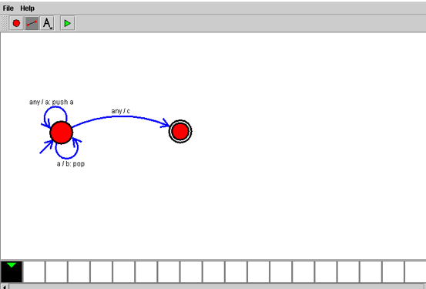

Result
Thus, the Push Down Automaton (PDA) was successfully designed and simulated to accept the language *L = { w | w ∈ a⁺b and nₐ(w) = nᵦ(w) }**. The PDA correctly accepted strings containing an equal number of a's followed by b's and rejected all other strings.

